**System Requirements Specifications for Roadie**

Sponsor

**Electrical, Computer, Software & Systems Engineering at Embry-Riddle Aeronautical University**

Released 18 September 2014

**Are We There Yet?**

Table of Contents

**Revision History** 5

**1.** **Introduction** 6

**1.1** **Purpose** 6

**1.2** **Problem Statement** 6

**1.3** **Scope** 6

**1.4** **Team Information** 6

**1.5** **Overview** 7

**2.** **Overall Description** 8

**2.1** **Stakeholders** 8

**2.2** **Product Perspective** 9

**2.3** **Product Functions** 8

**2.4** **Assumptions and Dependencies** 9

**2.5** **Use Cases** 9

**2.5.1** **Use Case 1: Full Completion of the Course** 9

**2.5.2** **Use Case 2: Simon Carabiner Challenge** 11

**2.5.3** **Use Case 3: Etch-A-Sketch Challenge** 13

**2.5.4** **Use Case 4: Rubik’s Cube Challenge** 15

**2.5.5** **Use Case 5: Card Challenge** 17

**2.5.6** **Use Case 6: Line Following** 19

**2.6** **Sequence Diagrams** 21

**2.6.1** **Use Case 1** 21

**2.6.2** **Use Case 2** 22

**2.6.3** **Use Case 3** 23

**2.6.4** **Use Case 4** 24

**2.6.5** **Use Case 5** 25

**2.6.6** **Use Case 6** 26

**3.** **Functional Requirements** 27

**3.1** **Movement** 27

**3.2** **Navigation** 27

**3.3** **Challenge Completion** 27

**4.** **Non-Functional Requirements** 28

**4.1** **System Size** 28

**4.2** **Power Management** 28

**4.3** **Start Method/Operation** 28

**5.** **Glossary** 29

**6.** **Acronyms and Abbreviations** 31

**7.** **Appendix A** 32

**7.1** **Competition Course** 32

**7.2** **Simon carabiner** 33

**7.3** **Rubik’s Cube** 34

**7.4** **Pocket Etch-A-Sketch** 35

**7.5** **Playing Cards** 36

**7.6** **Scotch Blue Painter’s Tape** 37

**8.** **References** 38

Table of Figures

**Fig. 1** Use Case: Full completion of the course sequence diagram 21

**Fig. 2** Use case: Simon Carabiner challenge sequence diagram 22

**Fig. 3** Use case: Pocket Etch-A-Sketch challenge sequence diagram. 23

**Fig. 4** Use case: Rubik’s Cube challenge sequence diagram 24

**Fig. 5** Use case: Card challenge sequence diagram. 25

**Fig. 6** Use Case: Line Following Sequence Diagram 26

**Fig. 7** Competition course for SoutheastCon[1]. 32

**Fig. 8:** The exact Simon Carabiner to be used during competition [5]. 33

**Fig. 9:** The exact Rubik's Cube to be used during competition [6]. 34

**Fig. 10:** The exact pocket Etch-A-Sketch to be used during competition [7]. 35

**Fig. 11:** The exact painter’s tape to be used on the course [8]. 37

# **Revision History**

|  |  |  |
| --- | --- | --- |
| Date | Reason for Change | Version |
| 18 Sep 2014 | Submission | 1.0.0 |
| 18 Sep 2014 | In class review | 0.8.0 |
| 17 Sep 2014 | Clarify requirements. Formatting changes. | 0.7.0 |
| 15 Sep 2014 | Jorge Peer Review | 0.6.0 |
| 12 Sep. 2014 | Style Formatting | 0.5.0 |
| 12 Sep 2014 | Added Use Cases and Sequence Diagrams | 0.4.0 |
| 10 Sep 2014 | Added Overall Description | 0.3.0 |
| 9 Sep 2014 | In-class revision | 0.2.0 |
| 7 Sep 2014 | Initial Draft | 0.1.0 |

# **Introduction**

The introduction describes the purpose of this document, as well as the problem that the system will solve. Additionally, the scope of the system and the team responsible for the systems design and construction is listed.

## **Purpose**

The purpose of this document is to define the system requirements of Roadie, the robot put forth by team Are We There Yet (AWTY) to compete in the 2015 Institute of Electrical and Electronics Engineers (IEEE) SoutheastCon student hardware competition. These requirements include both functional requirements and non-functional requirements. This document is intended for the customer of AWTY, the requirements engineering team for AWTY, the design, testing and quality assurance teams, as well as all other teams involved in the development and construction.

## **Problem Statement**

To create an autonomous robot to compete in the 2015 IEEE SoutheastCon student hardware competition.

## **Scope**

Roadie is intended to compete in the 2015 IEEE Southeast Con student hardware competition. The system is envisioned to complete four unique challenges:[1]

* Correctly play Simon for 15 seconds
* Draw “IEEE” on a pocket Etch-A-Sketch
* Twist one row of a Rubik’s Cube 180 degrees
* Pick up and carry one playing card across the finish line

Roadie system is intended to successfully complete the challenges outlined above within a time limit of five minutes.

Roadie is not intended to serve any other functions or fulfill any other purposes other than competing in the 2015 IEEE SoutheastCon competition.

## **Team Information**

|  |  |
| --- | --- |
| Name | Role |
| Brian Powell | Team Leader |
| Michael Philotoff | Software Configuration Manager |
| Alex Senopoulos | Testing Leader |
| Brian Sterling | Development Leader |

## **Overview**

Section 1 of this document serves as introduction to the system designed by AWTY. Section 2 provides an overall description of the system, including stakeholders involved in the project, the functions of the system and proposed use cases for the system. Section 3 describes the functional and Section 4 describes the non-functional requirements of the system.

The glossary contains definitions of all industry and standard terms as well as ambiguous terms, used throughout this document. Additionally, a list of acronyms and abbreviations can be found following the glossary. A picture of the course as well as the challenges are included in Appendix A.

# **Overall Description**

The overall description contains the use cases for the system as well as the accompanying sequence diagrams, the stakeholders, the perspective of the product, the functionality of the product and any assumptions or dependencies imposed upon the system.

## **Stakeholders**

The following list describes the individuals and parties involved in, or that have a stake in, the development, productions and operation of Roadie.

* + 1. **Team AWTY**

As the development team, there is a vested interest in terms of grades. The grades will be based upon the completion of the system, as well as meeting customer demands. Additionally, efforts should be made to apply principles and concepts learned while at Embry-Riddle Aeronautical University (ERAU).

* + 1. **Dr. Barott, Dr. Seker and Jorge Torres**

As customers of team AWTY, Dr. Barott, Dr. Seker and Jorge Torres are interested in the completion of the product as outlined in this document. Furthermore, Dr. Barott and Dr. Seker are interested in ensuring that the project meets the standards set forth by Department of Electrical, Computer, Software & Systems Engineering (ECSSE) at ERAU.

* + 1. **ERAU**

Since the University is an indirect sponsor of the project, any actions taken by the development team reflect directly back upon the University.

* + 1. **ECSSE Department**

As the direct sponsor of the project, the department is interested in making sure the project is delivered both on time and on budget.

* + 1. **IEEE**

As the sponsor of the competition for which the final system will compete in, the IEEE is interested in making sure that the final system complies with all competition rules and that the development team has conducted themselves in a manner befitting of a professional organization.

## **Product Functions**

Roadie is broken down into five major subsystems: (1) the line following subsystem, (2) the Simon Carabiner subsystem, (3) the pocket Etch-a-Sketch subsystem, (4) the Rubik’s Cube subsystem and (5) the playing card subsystem. The purpose of these subsystems is to facilitate the requirements engineering process.

## **Assumptions and Dependencies**

In order for the system to be successful during competition, the following assumptions and dependencies have been imposed upon the system.

* + 1. **Rules and Regulations**

The system described and outlined in this document abides by IEEE SoutheastCon 2015 Student Program - Hardware Competition [1], last updated 19 March 2014. Changes to the rules and regulations after publishing of this document will be addressed in a later revision.

## **Product Perspective**

Roadie system is intended to be an autonomous robot whose sole purpose is to compete in the IEEE 2015 SoutheastCon student hardware competition.

## **Use Cases**

The following use cases demonstrate the intended operations of Roadie. The use cases outline the intended sequence of events as well as the procedures that will be followed in the event of a system failure.

Note: “*” indicates at any given time, during the use case.

## **Use Case 1: Full Completion of the Course**

Scope: Roadie

Level: User goal

Primary Actors: Roadie

**Stakeholders & Interests**

* **Team AWTY**  - as the development team for Roadie, Roadie’s performance in the competition will reflect directly back upon them.
* **Dr. Barott, Dr. Seker and Jorge Torres –** as customers of Team AWTY, there is an expectation that Roadie will compete successfully in the competition.
* **ERAU –** the system represents the quality of the education at the University as well as the technical ability of the sponsors and the department.
* **ECSSE Department –** direct sponsor of Team AWTY expects Roadie to compete in and complete the competition to the best of its abilities.
* **IEEE –** competition sponsor expects Team AWTY to conduct themselves in a manner befitting of a professional organization as well as to demonstrate innovate solutions to technical challenges.

**Preconditions**

* Roadie has been placed in the 1 ft. x 1 ft. starting square on the competition area.
* Roadie has been turned to the on position.

**Postconditions**

* Roadie crosses the finish line holding a single playing card.

**Main Success Scenario**

1. Roadie waits for the red LED to turn off before entering into the Line Following State.
2. Roadie enters into the Line Following State and starts line following, making turns based on which way the line is turning until reaching the first challenge.
3. Roadie enters into the Challenge State and completes the first challenge as described in Use Case 2: Simon Carabiner Challenge.
4. Roadie enters into the Line Following State, turns around and begins to line follow until reaching the second challenge.
5. Roadie enters into the Challenge State and completes the second challenge as described in Use Case 3: Pocket Etch-A-Sketch Challenge.
6. Roadie enters into the Line Following State, turns around and beings to line follow until reaching the third challenge.
7. Roadie enters into the Challenge State and completes the third challenge as described in Use Case 4: Rubik Cube Challenge.
8. Roadie enters into the Line Following State, turns around and beings to line follow until reaching the fourth challenge.
9. Roadie enters into the Challenge State and completes the fourth challenge as described in Use Case 5: Card Challenge.
10. Roadie enters into the Line Following State, turns around and beings to line follow until crossing the finish line while holding onto a card.

**Extensions (Alternate Flows)**

*a. Roadie is in a bad state.

1. Roadie will backtrack last known good state.

2. Roadie shall proceed with the next steps to take.

**Frequency of Occurrence**

This use case will occur each time the system is placed within the 1 ft. x 1 ft. white square. During the competition this shall occur three times due to there being three rounds for each robot that is entered.

## **Use Case 2: Simon Carabiner Challenge**

Scope: Roadie

Level: User goal

Primary Actors: Roadie

**Stakeholders & Interests**

* **Team AWTY**  - as the development team for Roadie, Roadie’s performance in the challenge will reflect directly back upon them.
* **Dr. Barott, Dr. Seker and Jorge Torres –** as customers of Team AWTY, there is an expectation that Roadie will compete successfully in the challenge.
* **ERAU –** the system represents the quality of the education at the University as well as the technical ability of the sponsors and the department.
* **ECSSE Department –** direct sponsor of Team AWTY expects Roadie to compete in and complete the challenge to the best of its abilities.
* **IEEE –** competition sponsor expects Team AWTY to conduct themselves in a manner befitting of a professional organization as well as to demonstrate innovate solutions to technical challenges.

**Preconditions**

* Roadie has reached the Simon Carabiner challenge zone.

**Postconditions**

* Roadie completes playing Simon Carabiner for 15 seconds.

**Main Success Scenario**

1. Roadie correctly identifies the challenge to be the Simon Carabiner challenge.
2. Roadie aligns itself at the Simon Carabiner.
3. Roadie pushes the start button located on the Simon Carabiner.
4. Roadie correctly identifies which colors and order the Simon Carabiner has lit up.
5. Roadie pushes each button in the order at which the Simon Carabiner has lit up.
6. Roadie repeats steps 4 and 5 until 15 seconds has passed.

**Extensions (Alternate Flows)**

*a. Roadie fails to respond or correctly push buttons in order to where Simon signals the failure sound.

1. Roadie shall restart at step 3 again and continue on with steps 4 and 5 (this process does not reset the 15 second timer).

**Frequency of Occurrence**

This use case will occur every time Roadie reaches and identifies the challenge to be the Simon Carabiner challenge. During the competition this shall occur three times due to there being three rounds for each robot that is entered and this challenge shall occur once per round.

## **Use Case 3: Pocket Etch-A-Sketch Challenge**

Scope: Roadie

Level: User goal

Primary Actors: Roadie

**Stakeholders & Interests**

* **Team AWTY**  - as the development team for Roadie, Roadie’s performance in the challenge will reflect directly back upon them.
* **Dr. Barott, Dr. Seker and Jorge Torres –** as customers of Team AWTY, there is an expectation that Roadie will compete successfully in the challenge.
* **ERAU –** the system represents the quality of the education at the University as well as the technical ability of the sponsors and the department.
* **ECSSE Department –** direct sponsor of Team AWTY expects Roadie to compete in and complete the challenge to the best of its abilities.
* **IEEE –** competition sponsor expects Team AWTY to conduct themselves in a manner befitting of a professional organization as well as to demonstrate innovate solutions to technical challenges.

**Preconditions**

* Roadie has arrived at the pocket Etch-A-Sketch challenge zone.

**Postconditions**

* Roadie completes drawing “IEEE” using the pocket Etch-A-Sketch.

**Main Success Scenario**

1. Roadie correctly identifies the challenge to be the pocket Etch-A-Sketch challenge.
2. Roadie aligns itself with the pocket Etch-A-Sketch.
3. Roadie twists the two knobs to draw “IEEE” on the pocket Etch-A-Sketch (Font and Size [TBD]).

**Extensions (Alternate Flows)**

*a. Roadie is in a bad state.

1. Roadie will backtrack last known good state.

2. Roadie shall proceed with the next steps to take.

**Frequency of Occurrence**

This use case will occur every time Roadie reaches and identifies the challenge to be the pocket Etch-A-Sketch challenge. During the competition this shall occur three times due to there being three rounds for each robot that is entered and this challenge shall occur once per round.

## **Use Case 4: Rubik’s Cube Challenge**

Scope: Roadie

Level: User goal

Primary Actors: Roadie

**Stakeholders & Interests**

* **Team AWTY**  - as the development team for Roadie, Roadie’s performance in the challenge will reflect directly back upon them.
* **Dr. Barott, Dr. Seker and Jorge Torres –** as customers of Team AWTY, there is an expectation that Roadie will compete successfully in the challenge.
* **ERAU –** the system represents the quality of the education at the University as well as the technical ability of the sponsors and the department.
* **ECSSE Department –** direct sponsor of Team AWTY expects Roadie to compete in and complete the challenge to the best of its abilities.
* **IEEE –** competition sponsor expects Team AWTY to conduct themselves in a manner befitting of a professional organization as well as to demonstrate innovate solutions to technical challenges.

**Preconditions**

* Roadie has arrived at the Rubik’s Cube challenge zone.

**Postconditions**

* Roadie twisted a row of the Rubik’s Cube 180 degrees.

**Main Success Scenario**

1. Roadie correctly identifies the challenge to be the Rubik’s Cube challenge zone.
2. Roadie aligns itself with the Rubik’s Cube.
3. Roadie twist one of the rows of Rubik’s Cube 180 degrees.

**Extensions (Alternate Flows)**

*a. Roadie is in a bad state.

1. Roadie will backtrack last known good state.

2. Roadie shall proceed with the next steps to take.

**Frequency of Occurrence**

This use case will occur every time Roadie reaches and identifies the challenge to be the Rubik’s Cube challenge. During the competition this shall occur three times due to there being three rounds for each robot that is entered and this challenge shall occur once per round.

## **Use Case 5: Playing Card Challenge**

Scope: Roadie

Level: User goal

Primary Actors: Roadie

**Stakeholders & Interests**

* **Team AWTY**  - as the development team for Roadie, Roadie’s performance in the challenge will reflect directly back upon them.
* **Dr. Barott, Dr. Seker and Jorge Torres –** as customers of Team AWTY, there is an expectation that Roadie will compete successfully in the challenge.
* **ERAU –** the system represents the quality of the education at the University as well as the technical ability of the sponsors and the department.
* **ECSSE Department –** direct sponsor of Team AWTY expects Roadie to compete in and complete the challenge to the best of its abilities.
* **IEEE –** competition sponsor expects Team AWTY to conduct themselves in a manner befitting of a professional organization as well as to demonstrate innovate solutions to technical challenges.

**Preconditions**

* Roadie has arrived at the card challenge zone.

**Postconditions**

* Roadie has picked up a single playing card.

**Main Success Scenario**

1. Roadie correctly identifies the challenge to be the card challenge zone.
2. Roadie aligns itself with the deck of cards.
3. Roadie picks up a single playing card.
4. Roadie continues to carry the playing card that was picked up.

**Extensions (Alternate Flows)**

*a. Roadie is in a bad state.

1. Roadie will backtrack last known good state.

2. Roadie shall proceed with the next steps to take.

**Frequency of Occurrence**

This use case will occur every time Roadie reaches and identifies the challenge to be the playing card challenge. During the competition this shall occur three times due to there being three rounds for each robot that is entered and this challenge shall occur once per round.

## **Use Case 6: Line Following**

Scope: Roadie

Level: User goal

Primary Actors: Roadie

**Stakeholders & Interests**

* **Team AWTY**  - as the development team for Roadie, Roadie’s performance in the challenge will reflect directly back upon them.
* **Dr. Barott, Dr. Seker and Jorge Torres –** as customers of Team AWTY, there is an expectation that Roadie will compete successfully in the challenge.
* **ERAU –** the system represents the quality of the education at the University as well as the technical ability of the sponsors and the department.
* **ECSSE Department –** direct sponsor of Team AWTY expects Roadie to compete in and complete the challenge to the best of its abilities.
* **IEEE –** competition sponsor expects Team AWTY to conduct themselves in a manner befitting of a professional organization as well as to demonstrate innovate solutions to technical challenges.

**Preconditions**

* Roadie has been placed in the 1 ft. x 1 ft. starting square on the competition area.
* Roadie has been turned to the on position.

**Postconditions**

* Roadie crosses the finish line.

**Main Success Scenario**

1. Roadie waits for the red LED to turn off before entering into the Line Following State.
2. Roadie enters into the Line Following State and starts line following making turns based on which way the line is turning until reaching the first challenge.
3. After completing the first challenge, Roadie turns around and begins to line follow until reaching the second challenge.
4. After completing the second challenge, Roadie turns around and beings to line follow until reaching the third challenge.
5. After completing the third challenge, Roadie turns around and beings to line follow until reaching the fourth challenge.
6. After completing the fourth challenge, Roadie turns around and beings to line follow until crossing the finish line.

**Extensions (Alternate Flows)**

*a. Roadie is in a bad state.

1. Roadie will backtrack last known good state.

2. Roadie shall proceed with the next steps to take.

**Frequency of Occurrence**

This use case will occur each time the system is placed within the 1 ft. x 1 ft. white square. During the competition this shall occur three times due to there being three rounds for each robot that is entered.

## **Sequence Diagrams**

The following sequence diagrams demonstrate the sequence of events Roadie will take in each use case.

## **Use Case 1**

**For the Use Case**: Full completion of the Course Sequence Diagram as shown in **Fig. 1** below shows how the system will communicate with its self to complete the course for the 2015 IEEE SoutheastCon competition.

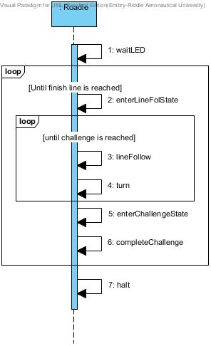

**Fig. 1** Use Case: Full completion of the course sequence diagram

## **Use Case 2**

**For the Use Case:** Simon Carabiner Challenge Sequence Diagram as shown in **Fig. 2** below shows the steps Roadie shall take in order to complete the Simon Carabiner Challenge.

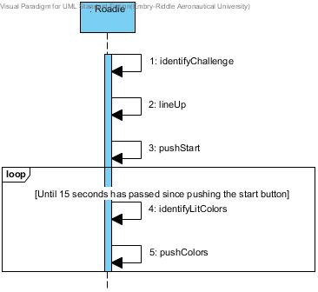

**Fig. 2** Use case: Simon Carabiner challenge sequence diagram

## **Use Case 3**

**For the Use Case:** Pocket Etch-A-Sketch Challenge Sequence Diagram as shown in **Fig. 3** below shows the steps Roadie shall take in order to complete the pocket Etch-A-Sketch challenge.

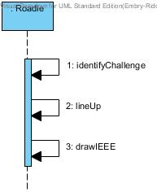

**Fig. 3** Use case: Pocket Etch-A-Sketch challenge sequence diagram.

## **Use Case 4**

**For the Use Case:** Rubik Challenge Sequence Diagram as shown in **Fig. 4** below shows the steps Roadie shall take in order to complete the Rubik’s Cube challenge.

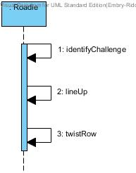

**Fig. 4** Use case: Rubik’s Cube challenge sequence diagram

## **Use Case 5**

**For the Use Case:** Card Challenge Sequence Diagram as shown in **Fig. 5** below shows the steps Roadie shall take in order to complete the card challenge.

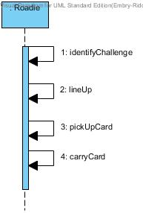

**Fig. 5** Use case: Card challenge sequence diagram.

## **Use Case 6**

**For the Use Case:** Line Following Sequence Diagram depicted in **Fig. 6** shows the steps Roadie shall take in order to line follow from start to finish on the competition area.

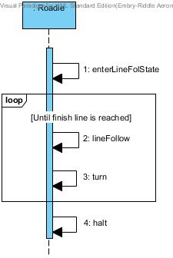

**Fig. 6** Use Case: Line Following Sequence Diagram

# **Functional Requirements**

The functional requirements define the functions of Roadie, as well as Roadie’s components.

* 1. **Movement**
     1. The system shall move in the competition area shown in **Fig. 7**.
     2. The system shall move from the starting area to the Simon Carabiner along the Scotch Blue Painter’s tape (guidance tape).
     3. The system shall move from the Simon Carabiner to the pocket Etch-a-Sketch along the guidance tape.
     4. The system shall move from the pocket Etch-a-Sketch to the Rubik’s Cube along the guidance tape.
     5. The system shall move from the Rubik’s Cube to the deck of playing cards along the guidance tape.
     6. The system shall move from the deck of playing cards to the finish line along the guidance tape.
     7. The system shall wait for red [RGB value TBD] LED in starting area to turn off before exiting the starting area.
  2. **Navigation**
     1. The system shall start in the starting area.
     2. The system shall progress forward along the blue guidance tape until reaching a challenge area or reaching the finish line.
     3. The system shall identify the challenge zone and stop movement upon arrival.
  3. **Challenge Completion**
     1. The system shall correctly identify the challenge upon arrival.
        1. The system correctly identifies the Simon Carabiner depicted in **Fig. 8**.
        2. The system correctly identifies the Rubik’s Cube depicted in **Fig. 9.**
        3. The system correctly identifies the pocket Etch-A-Sketch depicted in **Fig. 10**.
        4. The system correctly identifies the playing cards depicted in **Fig.** [TBD].
     2. The system shall align with the challenge before attempting to complete the challenge.
     3. The system shall play the Simon Carabiner.
        1. The system shall play the Simon Carabiner for 15 seconds.
        2. The system shall initiate the Simon Carabiner by pressing the start button.
        3. The system shall correctly sense color blue [exact RGB values TBD] when illuminated on the Simon Carabiner.
        4. The system shall correctly sense color red [exact RGB values TBD] when illuminated on the Simon Carabiner.
        5. The system shall correctly sense color yellow [exact RGB values TBD] when illuminated on the Simon Carabiner.
        6. The system shall correctly sense color green [exact RGB values TBD] when illuminated on the Simon Carabiner.
        7. The system shall not obstruct the Simon Carabiner during play.
        8. The system shall respond to the last color in the Simon sequence within [TBD] amount of time.
     4. The system shall twist one row of a Rubik’s Cube 180 degrees.
        1. The system shall not obstruct the Rubik’s Cube during play.
     5. The system shall draw “IEEE” on the pocket Etch-A-Sketch.
        1. The system shall use [Font and Size TBD] for drawing “IEEE”.
        2. The system shall not obstruct the pocket Etch-A-Sketch during play.
     6. The system shall collect a single playing card [Exact deck TBD].
        1. The system shall carry playing card across finish line.
        2. The system shall keep the card in a usable condition.

# **Non-Functional Requirements**

The non-functional requirements elaborate the performance characteristics of Roadie.

* 1. **System Size**
     1. The system size shall be no greater than 1ft. x 1ft. x 1ft. within the starting area and the finishing area.
  2. **Power Management**
     1. The system shall operate for a minimum of [TBD] minutes when the power source starts with a full charge.
  3. **Start Method/Operation**
     1. The system shall have an easily accessible power switch.
     2. The system shall be completely autonomous after being powered on.
     3. The system shall maintain contact with the competition area’s surface at all times.

# **Glossary**

The glossary contains definitions of words and phrases used throughout this document.

|  |  |  |
| --- | --- | --- |
| Entry | Definition | Aliases |
| Align | The system will position itself so the appendages can properly reach the challenges. |  |
| Autonomous | Undertaken or carried on without outside control [2]. |  |
| Bad state | Any state that is not the line following state or the challenge state. |  |
| Challenge State | The state in which Roadie is completing one of the four challenges. |  |
| Challenge Zone | The 1ft. x 1ft. areas where each of the challenges will be played along the course. |  |
| Competition Area | The competition area is the plywood board where the competition is being held on. The system must maintain contact with the board at all times. |  |
| Course Round | A span of five minutes during which the system is expected to complete the 4 challenges [1]. |  |
| Pocket Etch-A-Sketch | The pocket Etch-A-Sketch is a popular children’s toy with two knobs to move the cursor up and down as well as left and right. For the competition, the specific version of the pocket Etch-A-Sketch being used is SKU:FD79DD3F from Toys R Us online [7], and can be seen in **Fig. 10.** |  |
| Finish Line | The finish line is the ending point of the competition. It is the point where the Scotch Blue Painter’s Tape comes to the final “T” shape on the course [1]. It is marked as FINISH in **Fig. 7**. |  |
| Good state | Either the line following state or the challenge state. |  |
| Institute of Electrical and Electronics Engineers | “IEEE is the world's largest professional association dedicated to advancing technological innovation and excellence for the benefit of humanity” [4]. That being said, IEEE is not only composed of electronic and electrical engineers as the name might suggest. Other types of members include computer scientists, software developers and even some doctors. | IEEE |
| Line Following State | The state in which Roadie is following the Scotch Blue Painter’s tape located on the competition area. |  |
| Obstruct | SoutheastCon rules state that the system cannot obstruct any obstacle [1]. |  |
| Playing Card | Information on the specific playing cards is still pending, thus, [TBD]. |  |
| Rubik’s Cube | The Rubik’s Cube is a puzzle game that achieved popularity in the 1980’s. For the competition, the specific version of the Rubik’s Cube being used is SKU:DAD09D9E from Toys R Us online [6], and can be seen in **Fig. 9.** |  |
| Scotch Blue Painter’s Tape | Scotch Blue is a brand of painter’s tape produced by the company 3M. For the competition, the specific model of painters tape being used is SKU: 958999 from Home Depot [8], and can be seen in **Fig. 11.** | Guidance Tape |
| Simon Carabiner | The Simon Carabiner is another version of the game, Simon, which is an electronic version of the children’s game “Simon Says”. For the competition, the specific version of Simon being used is SKU:226CE810 from Toys R Us online [5], and can be seen in **Fig. 8.** |  |
| SoutheastCon | SoutheastCon is the annual IEEE Region 3 Technical, Professional, and Student Conference. The conference includes technical sessions, tutorials, and exhibits. Additionally, various challenges and competitions are held for students to demonstrate their technical knowledge and understanding.“IEEE Region 3 encompasses the southeastern United States and includes the states of Alabama, Florida, Georgia, areas of Indiana, Kentucky, Mississippi, North Carolina, South Carolina, Tennessee, Virginia and the country of Jamaica” [3]. |  |
| Starting Area | A one foot by one foot area on the competition area marked by Scotch Blue Painter’s tape [1]. |  |
| Usable Condition | SoutheastCon rules state that the playing card must be left in a usable condition [1]. |  |

# **Acronyms and Abbreviations**

|  |  |
| --- | --- |
| Acronym | Meaning |
| AWTY | Are We There Yet |
| ECSSE | Electrical, Computer, Software & Systems Engineering |
| ERAU | Embry-Riddle Aeronautical University |
| IEEE | Institute of Electrical and Electronics Engineers |

# **Appendix A**

This appendix includes a diagram of the competition course as well as pictures of the individual challenges the system must complete. Also included is a picture of the tape that will designate the line the system must follow.

## **Competition Course**

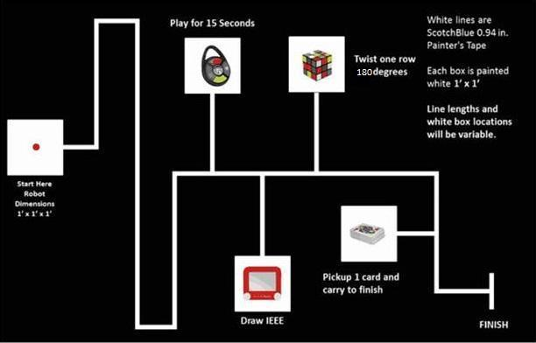The course, as shown in **Fig. 6** below, shows the rough outline of the track the system will follow, as well as what a challenge station would look like.

**Fig. 7** Competition course for SoutheastCon[1].

## **Simon Carabiner**

The Simon Carabiner, as seen in **Fig. 7** is the specific Simon game that the system will play.

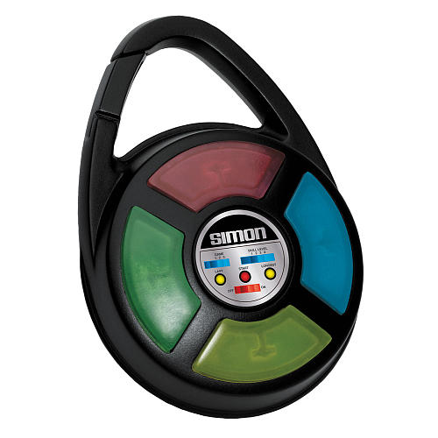

**Fig. 8:** The exact Simon Carabiner to be used during competition [5].

## **Rubik’s Cube**

The Rubik’s Cube, as seen in **Fig. 8** is the specific Rubik’s Cube that the system will play.

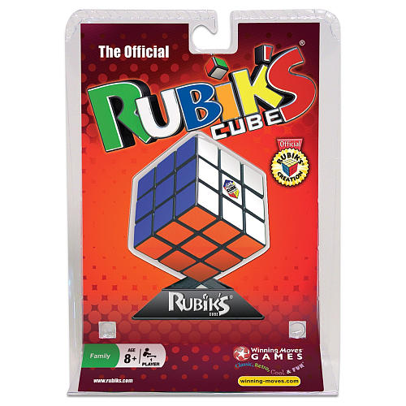

**Fig. 9:** The exact Rubik's Cube to be used during competition [6].

## **Pocket Etch-A-Sketch**

The pocket Etch-A-Sketch as shown in **Fig. 9** is the specific pocket Etch-A-Sketch the system will play.

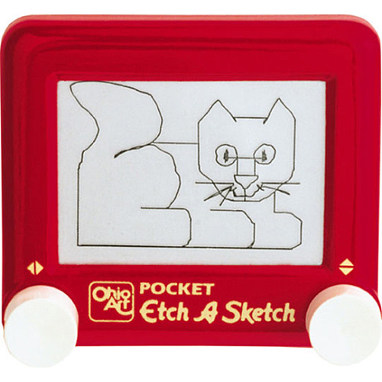

**Fig. 10:** The exact pocket Etch-A-Sketch to be used during competition [7].

## **Playing Cards**

[TBD] The playing cards will be updated with an appropriate picture once there is a specific set listed in the competition rules.

## **Scotch Blue Painter’s Tape**

The Scotch Blue Painter’s Tape as show in **Fig. 10** is the exact painter’s tape that will be used to designate the line the system must follow.

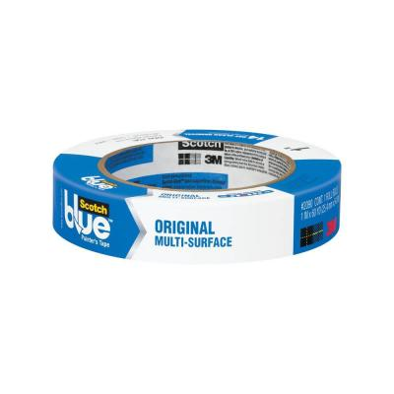

**Fig. 11:** The exact painter’s tape to be used on the course [8].

# **References**

[1] IEEE Nova Southeastern University. (2014, September 7). IEEE SoutheastCon 2015 Student Program - Hardware Competition. Retrieved September 7, 2014, from IEEE SoutheastCon 2015: http://www.ewh.ieee.org/reg/3/southeastcon2015/StudentProgram.html

[2] Rembold, U., & Fatikow, S. (1997). Autonomous Microbots. Journal of Intelligent and Robotic Systems, 19(4), 1.

[3] SoutheastCon. (n.d.). Retrieved September 13, 2014, from http://www.ewh.ieee.org/reg/3/southeastcon/

[4] "IEEE About IEEE." IEEE. N.p., n.d. Web. 12 Sept. 2014, from http://www.ieee.org/about/index.html.

[5] Simon Carabiner. (n.d.). Retrieved September 15, 2014, from http://www.toysrus.com/buy/card-puzzle-games/simon-carabiner-1850-3839349

[6] Rubik's 3x3 Cube. (n.d.). Retrieved September 16, 2014, from http://www.toysrus.com/buy/brain-teasers/rubik-s-3x3-cube-wm5027-29224016

[7] Pocket Etch A Sketch - Red. (n.d.). Retrieved September 16, 2014, from http://www.toysrus.com/buy/etch-a-sketch-doodle-pro/pocket-etch-a-sketch-red-5163-2395954

[8] 3M 0.94 in. x 60 yds. Painter's Tape-2090-24J at The Home Depot. (n.d.). Retrieved September 16, 2014, from http://www.homedepot.com/p/ScotchBlue-0-94-in-x-60-yds-Painter-s-Tape-2090-1J/100085823

1. The SKUs for the items used in the challenges can be found in the glossary. Pictures of the exact items can be found in Appendix A.